**Online Counseling Appointment Booking System.**

**Authors**

Cetric Okola S13/09717/15

Elvis Mutende SP13/00820/15

Alex Nyabuto S13/09721/15

Justus Luganu SP13/20012/14

Peter Makori S13/09722/15

Table of Contents

EXECUTIVE SUMMARY 4

SYSTEM REQUEST 5

PROJECT TEAM WORK PLAN 6

FEASIBILITY ANALYSIS. 8

BRIEF DESCRIPTION 9

SYSTEM REQUIREMENTS 10

FUNCTIONAL MODELS 11

Use Case Diagrams 11

Major use case 11

Use Case 1 11

Use Case 2 12

Use Case 3 13

Use Case 4 14

Use Case Descriptions 15

Activity Diagram 18

BEHAVIOURAL MODELS 19

Sequence Diagram 19

Communication Diagram 20

STRUCTURAL MODELS 21

CRC Cards 21

Class Diagram 24

Contract Forms 25

DATABASE STRUCTURE 30

USER INTERFACES 31

Student 31

Counsellor 33

Dean 35

APPENDIX 38

CONCLUSION 39

# EXECUTIVE SUMMARY

Group five is a software development company that will develop a system to facilitate online counseling appointment booking for the Egerton university Dean of Students Office needs to shift from the use of manual system to an on line student counseling appointment booking System.

This document is the system proposal for Egerton University Dean of Students Counseling Department. It provides detailed descriptions of the software, user and hardware interfaces of the system, and includes a detailed description of the user interface for the system.

The objective of this proposal is to provide a picture of the would be system as far as the pre-development stage of the project is concerned. It provides an outline of the system from the client's perspective.

The system shall be developed and implemented within three months

# SYSTEM REQUEST

Online Counseling Appointment Booking System.

Project Sponsor:

Egerton University

Business need:

A system to facilitate smooth booking of the appointments by the students to ease planning for counseling.

Business requirements:

All the logs of the week should be printed.

I want the system to automatically show the free counselors during the day.

The system should be able to respond to triggers.

Business value:

Track the counseling process is kept.

Time consumption is reduced on both the student side and counselor side.

Reduced paper work.

Special issues:

There are no special issues or constraints to the system.

|  |
| --- |
| PROJECT TEAM WORK PLAN |

|  |  |  |  |  |
| --- | --- | --- | --- | --- |
| Project Name | Online Counseling Appointment Booking System. | | | |
| Team Members | Cetric Okola S13/09717/15 Elvis Mutende SP13/00820/15  Alex Nyabuto S13/09721/15 Justus Luganu SP13/20012/14  Peter Makori S13/09722/15 | | | |
| Project Sponsor: Egerton University Computer Science Department.  Duration: 3 Months | | | Start Date:  End Date: | |
| What needs to be done? | | Who will do this part? | Duration in days | Done |
| Planning:  -project initiation  -System request  -feasibility analysis  -Work plan  -Staffing of project  -Contract forms  -Appendix | | All members  Cetric Okola  Elvis Mutende  Alex Ogendo  Elvis Mutende  Justus Luganu  Makori Peter | 0.3 Months | |  | | --- | |  | |
| Analysis:  -Analysis strategy  -Requirement gathering  -Analysis models  -System proposal | | All members  All members  All members  All members | 0.5 Months | |  | | --- | |  | |
| Design:  -Design strategy  -Use Case diagrams  -Use Case descriptions  -Activity Diagram  -Sequence Diagrams  -CRC Cards  -Communication Diagram  -Contract Forms  -Database Structure  -User Interfaces  -Program Design | | All members  Alex Ogendo  Alex Ogendo  Makori Peter  Elvis Mutende  Cetric Okola  Justus Luganu  Elvis, Cetric  Justus Luganu  Peter, Alex, Elvis  All Members | 1 Month | |  | | --- | |  | |
| Implementation:  -System Construction  -System Installation  -Training Plan  -Support Plan | |  | 1.5 Months | |  | | --- | |  | |
| Maintenance: | |  | 0.2 Months | |  | | --- | |  | |

# FEASIBILITY ANALYSIS.

1. Technical Feasibility

The system will accommodate all the Students and members of counselling department within Egerton University.

The system will be a web based system.

The users will be required to use mobile phones, laptops, tablets or desktop computers which are fully connected to the internet.

Most of the Student have smart phone and also the school provide resource centers with enough computers which are fully connected to the internet.

Then counselling department has internet connection.

Most of areas within Egerton Universities have internet access.

1. Economic Feasibility

The System will be affordable for Egerton University at no cost.

The System will require update cost for improvement if new features are later discovered after its development.

There will be no cost during development of the system.

1. Organizational Feasibility

The system will be of use within Egerton University.

The users are divided in 3 categories:

1. Students who book Appointments to see counsellors
2. Counsellors who attend to appointment of student
3. Dean of Student who oversee the entire process

# BRIEF DESCRIPTION

A system that will allow students book appointments to see counsellors and the dean of Students in Egerton University Njoro Campus.

**Constraints**

The system can work best on a pc, tablet or phone that can access internet.

System Objectives

1. To minimize time consuming to both the students and the dean.
2. To minimize paper work.
3. To enable easy retrieval of reports and logs.
4. To enhance data integrity and integrity among staff.

**Benefits Of The System**

1. Proper time management.
2. Enhance accountability among the staff.

Users of the System

The System will be used by Egerton Students, counsellors and Dean of Students in Egerton University - Njoro campus and their Staff members.

**The System Will:**

1. Allow users to interact with the system.
2. Allow student to book appointment see counsellors
3. System notifies the counsellors in case of appointments.
4. Allow counsellors set their schedule.
5. Allow dean of student oversee all the counselling activities within the school
6. Print appointment reports at any time it is required to.

**Methods Used To Collect Data:**

* Interviews.
* Observation.

# SYSTEM REQUIREMENTS

**Non-Functional Requirements**

**Operational**

* It will operate in windows/Unix Environment
* It will be web based system
* The system should be able to lift data from existing student’s portal database

**Performance**

* After every successful booking the system will increment the next booking time by 45min.
* The system should be able to update the log history after every log.
* Only counsellors will set their availability
* A student should log in using his/her registration number (which is unique) and a password.

**Functional Requirements:**

Students can make new appointments.

Only one appointment can be made by one student in a day.

Counsellors can set their schedules.

Dean can oversee the counselling process

# FUNCTIONAL MODELS

## Use Case Diagrams

### Major use case

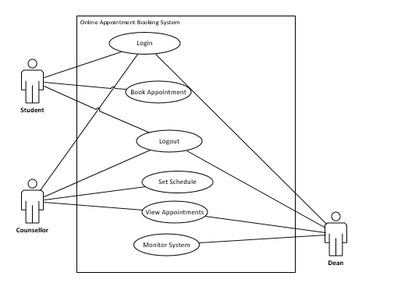

Use Case 1

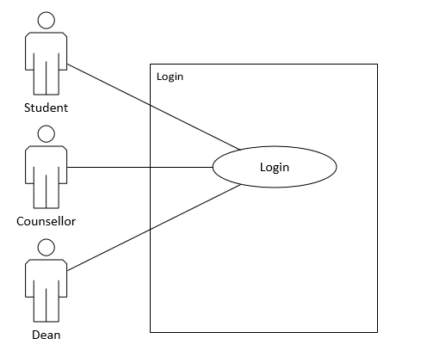

Use Case 2

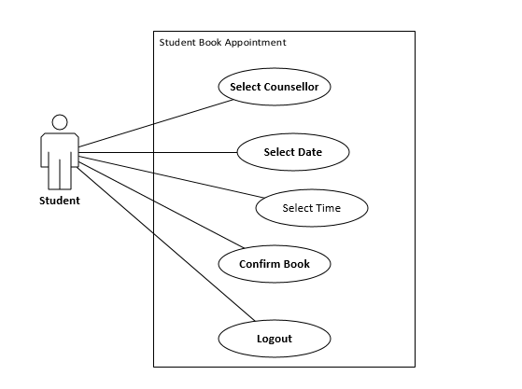

Use Case 3

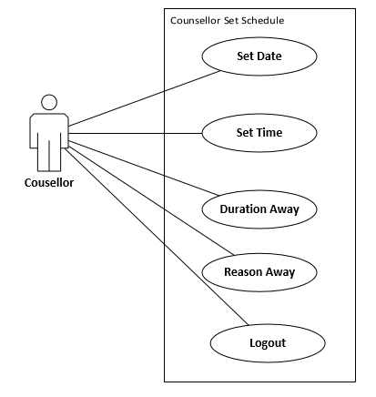

### Use Case 4

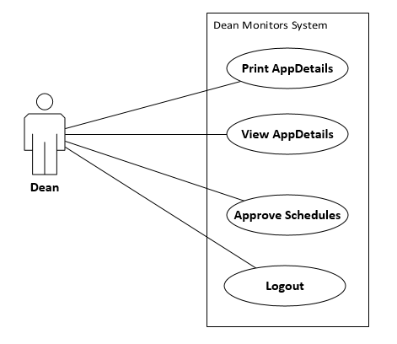

## Use Case Descriptions

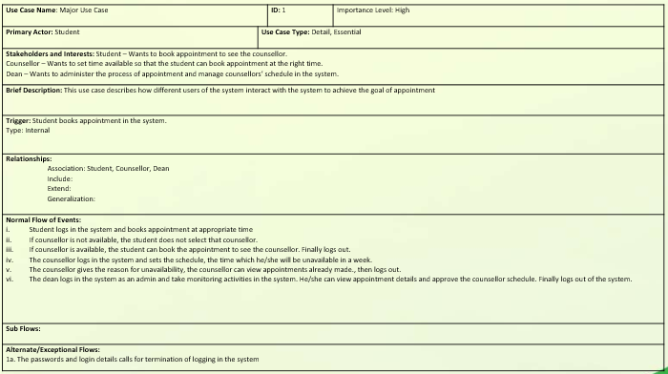

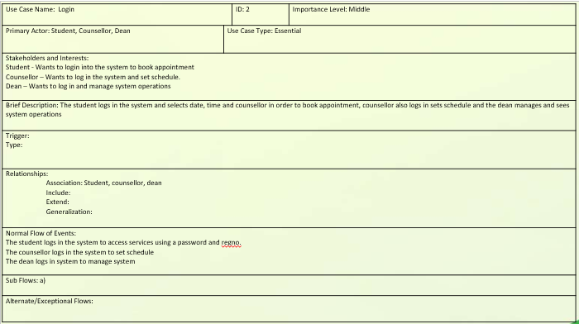

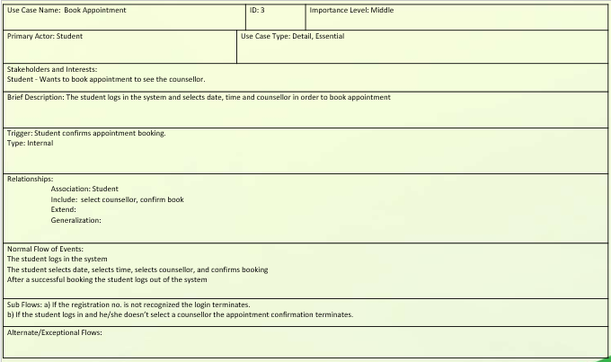

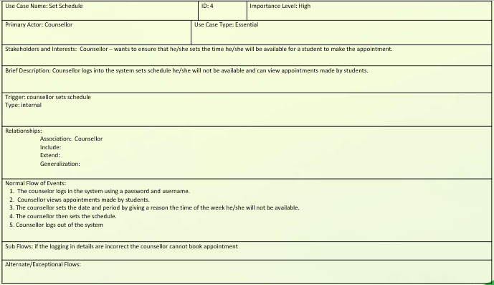

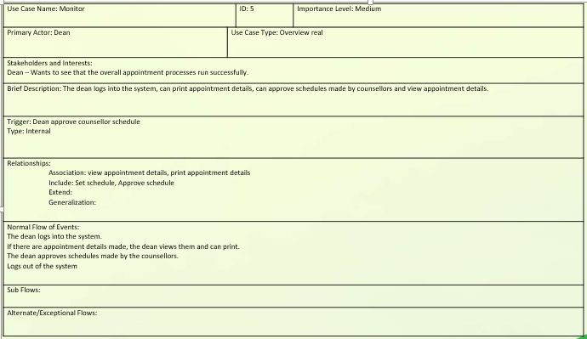

Activity Diagram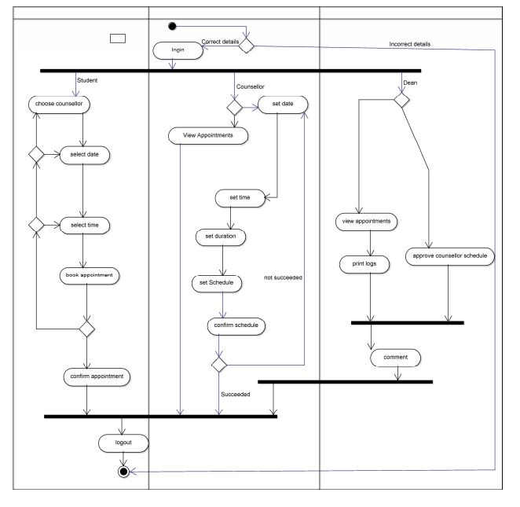

# BEHAVIOURAL MODELS

## Sequence Diagram

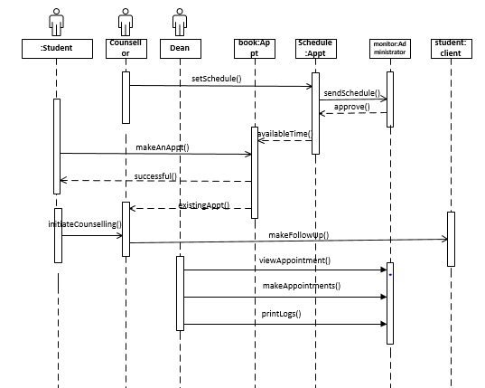

## Communication Diagram

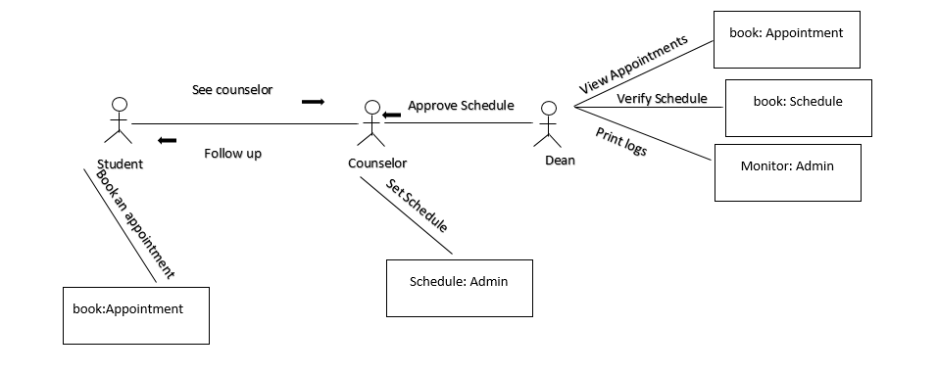

# STRUCTURAL MODELS

## CRC Cards

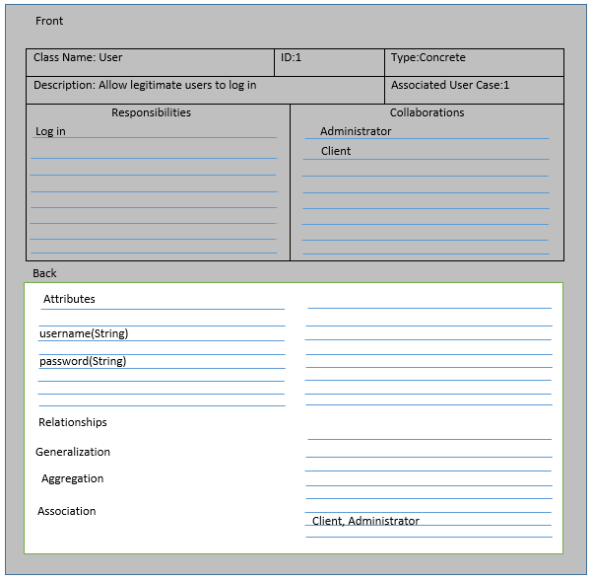

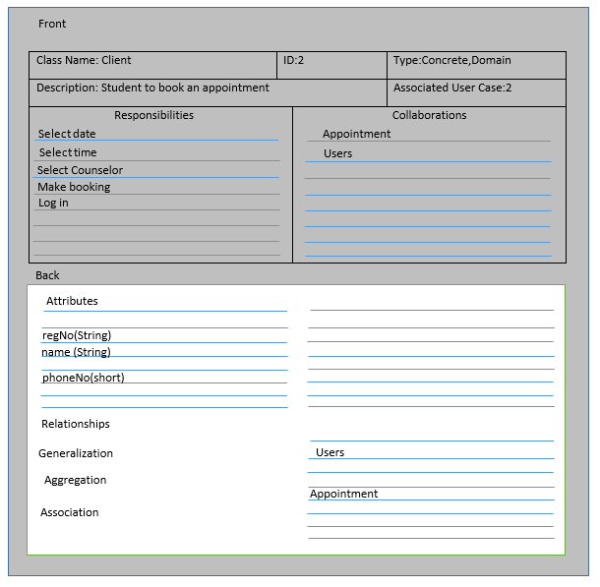

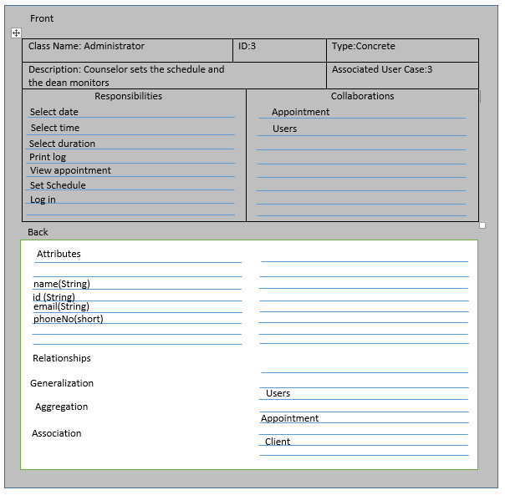

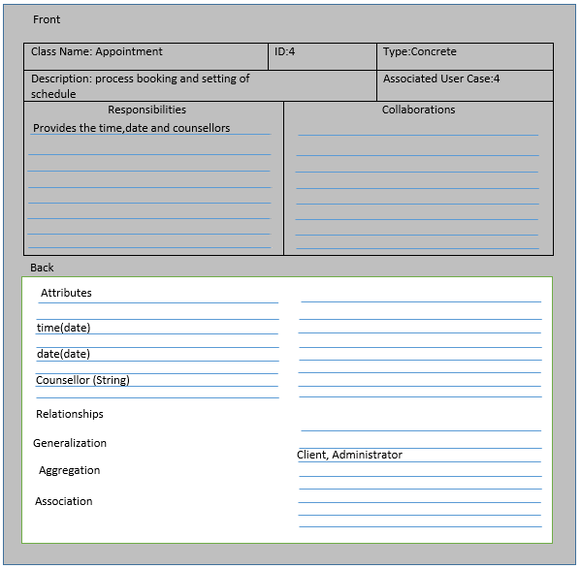

## Class Diagram

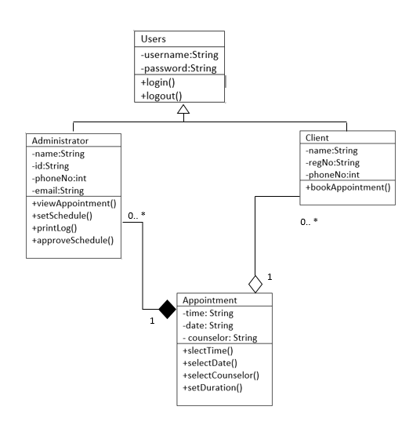

## Contract Forms

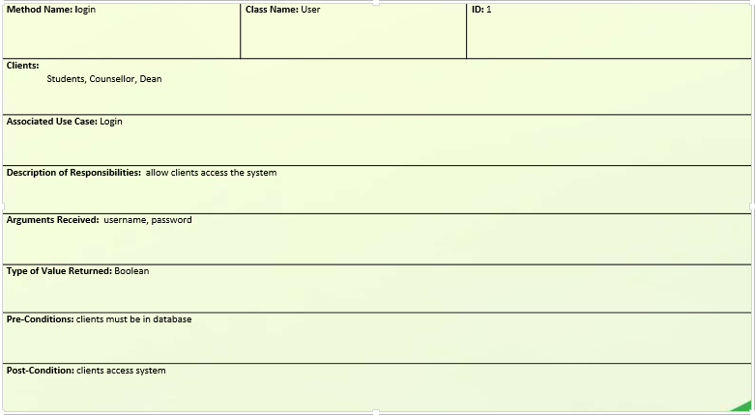

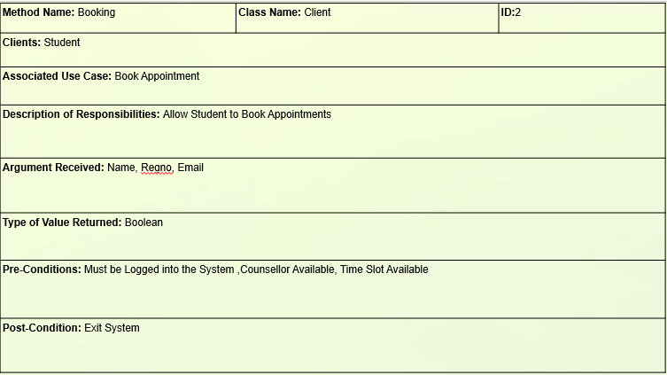

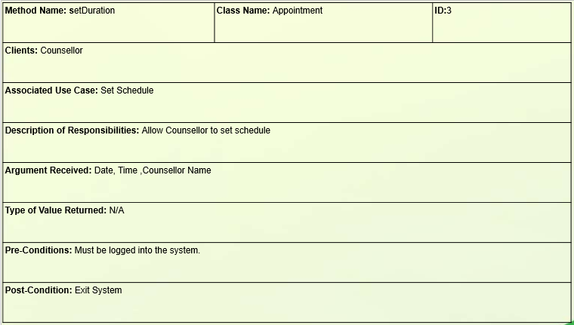

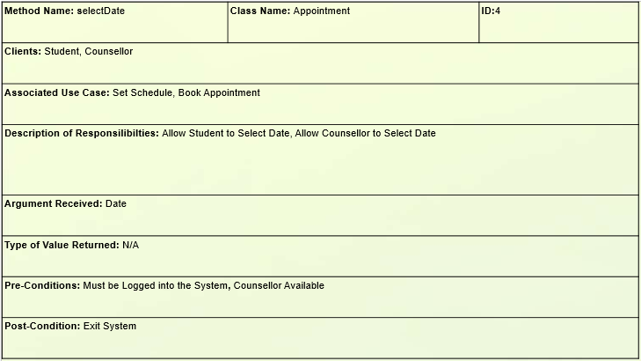

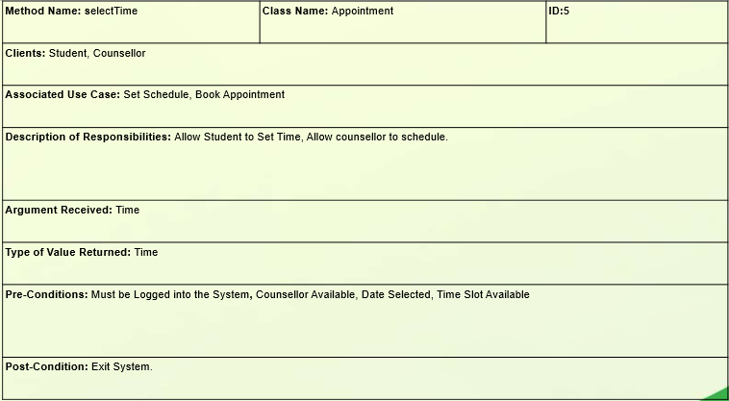

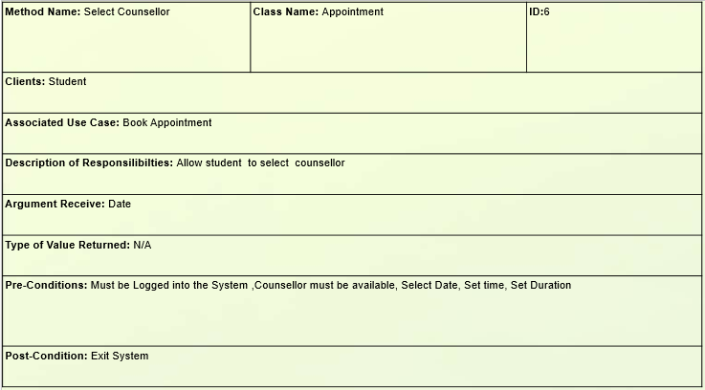

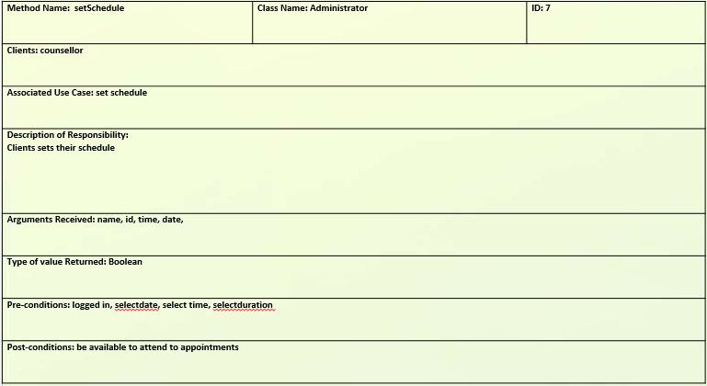

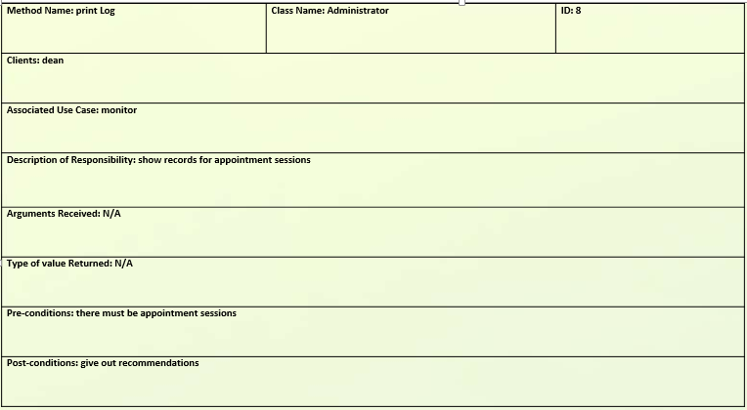

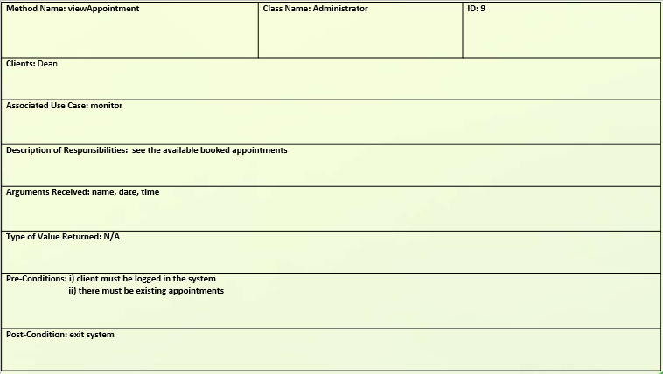

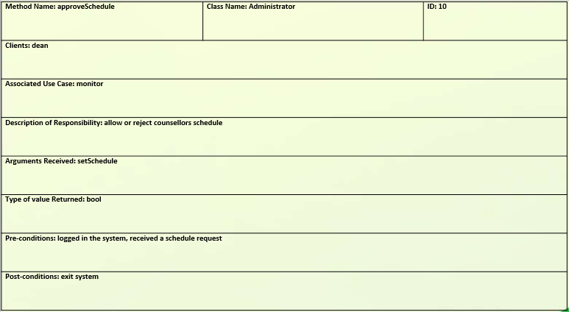

# DATABASE STRUCTURE

Relational Databases.

A relational database is based on collections of tables with each table having a primary key. A field or fields whose values are unique for every row of the table.

Strengths of Relational Databases.

Leader in the database market

Can handle diverse data needs

Good future prospects.

Organization dependent

Database Schema.

Sessions (studentReg, nameOftheCounsellor,counsellingDate, startTime , endTime,sessionId)

student (studentReg, userName, passWord, phoneNumber,email)

counsellors (counsellorNumber, Name, Phone_Number, Email)

admin (adminID, userName, passWord).

# USER INTERFACES

## Student

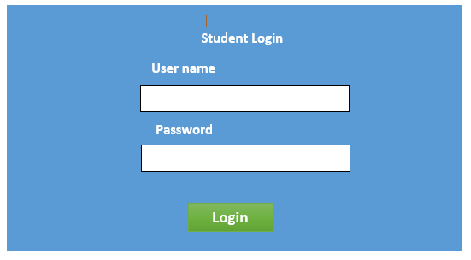

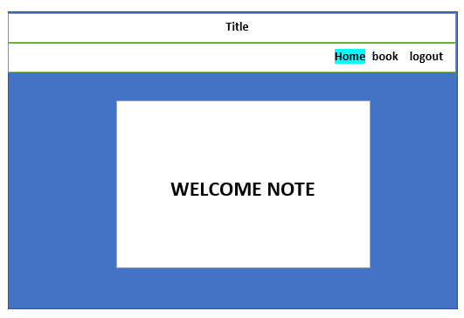

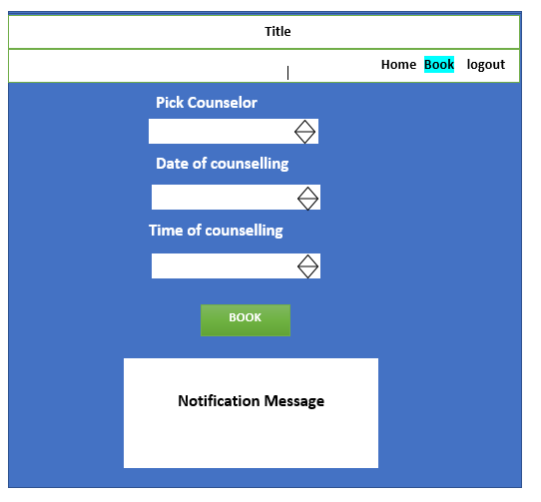

## Counsellor

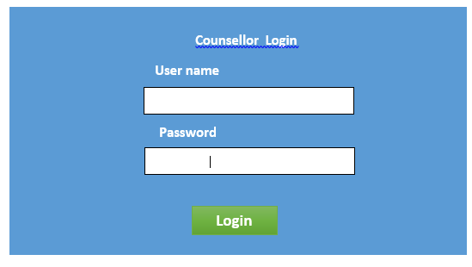

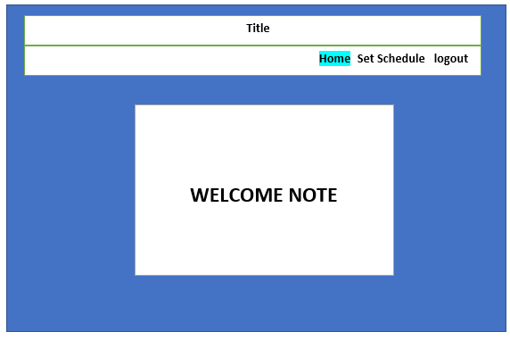

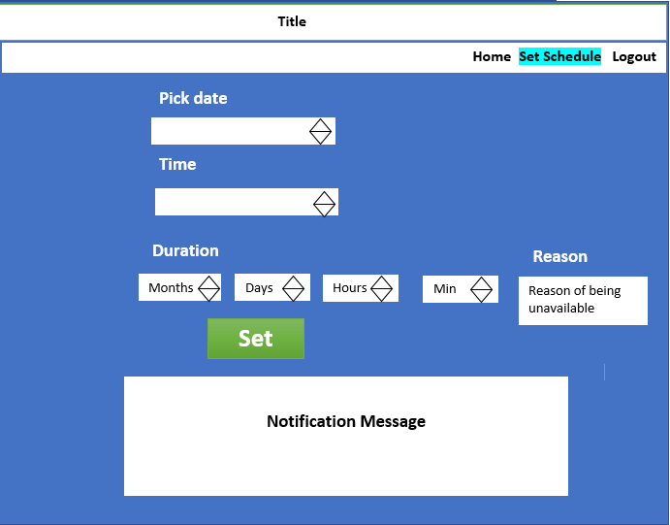

## Dean

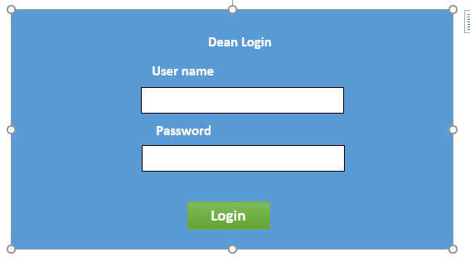

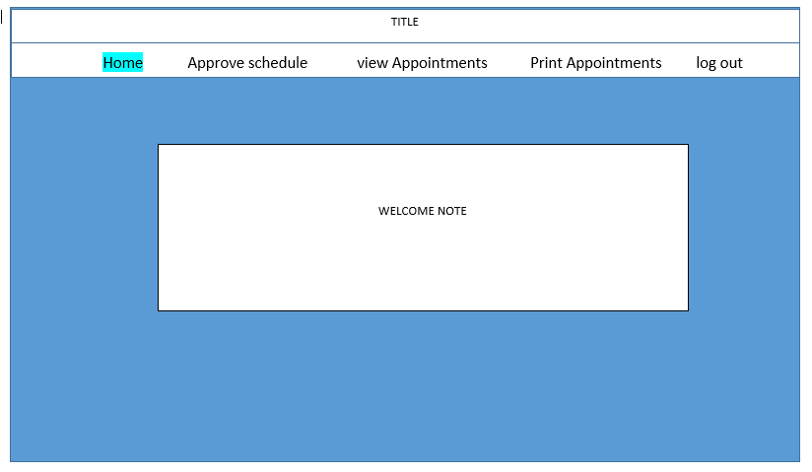

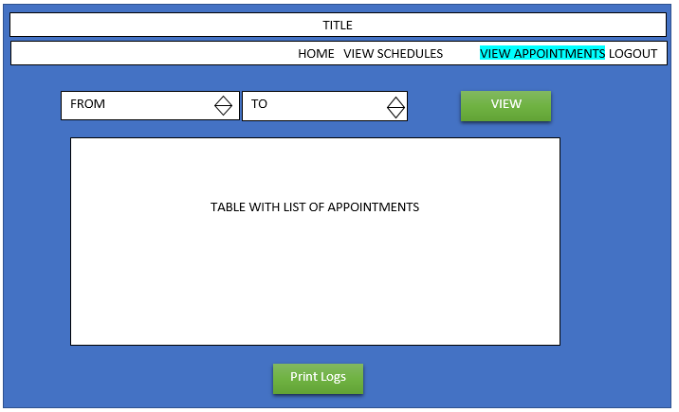

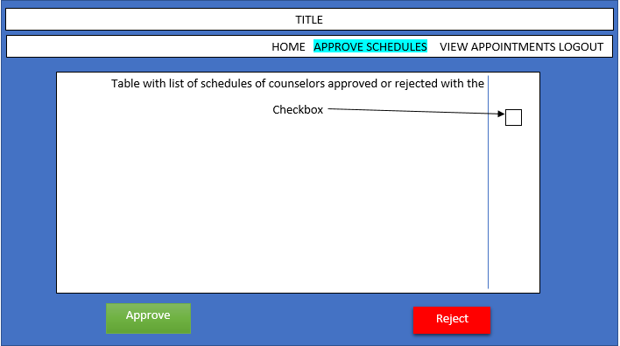

# APPENDIX

Interviews were conducted in order to gather adequate requirements before embarking to system analysis and design.

All the interviews were conducted in person to the counsellors and the dean in a private setting and the findings were recorded on paper.

The interview was held in participant’s office at 2.00 p.m., 15th October 2017. The researchers’ time with interviewees was limited to 50 minutes by their being busy with the schedule.

The interview preceded on a very structured path defined by preliminary questions set used by the interviewers to ensure coverage of the topics of importance to the researcher.

Three persons were interviewed in a private setting. These were:

Mr. Omwoyo - The Assistant dean of students

Mr. Keton - Counsellor

Mrs. Nyagaya - counsellor

According to the findings, the interviewees fully complemented the development of the system.

# CONCLUSION

The system will be required to perform efficiently as documented and allow room for improvement or changes if any.